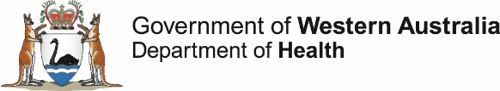

**OzFoodNet Enteric Disease Surveillance Report 3rd Quarter 2019**

This report describes enteric disease surveillance and investigations carried out during the third quarter of 2019 (3Q19) by OzFoodNet WA in conjunction with other Western Australian Department of Health agencies and local governments.

Some of the increase in notifications is likely to be due to the introduction of polymerase chain reaction (PCR) testing of faecal specimens which has greater sensitivity than culture techniques.

**Enhancing foodborne disease surveillance across Australia**

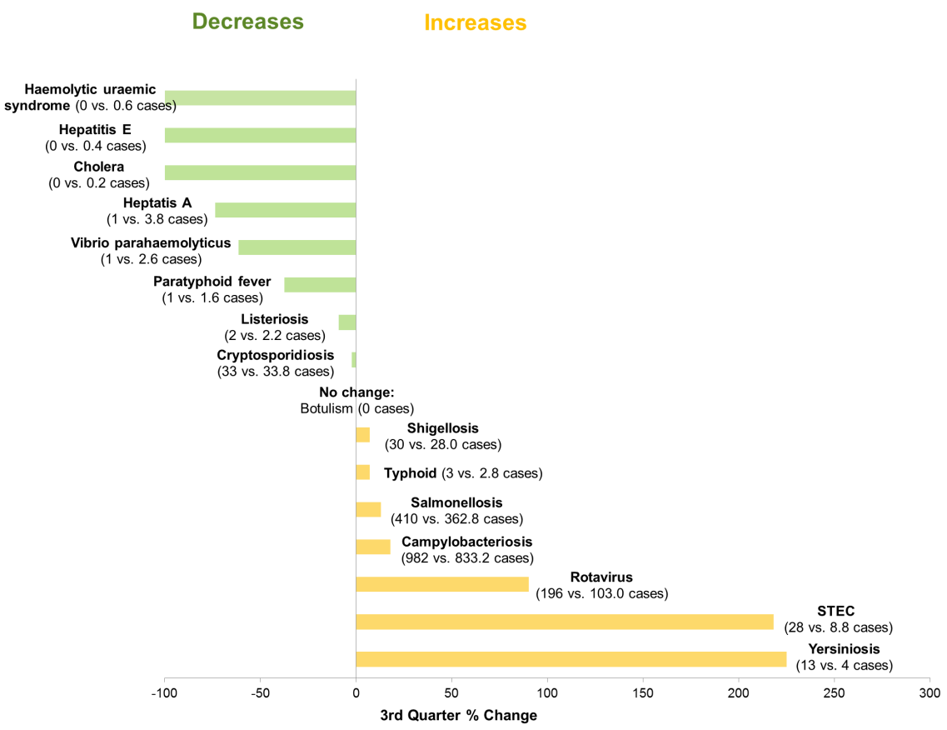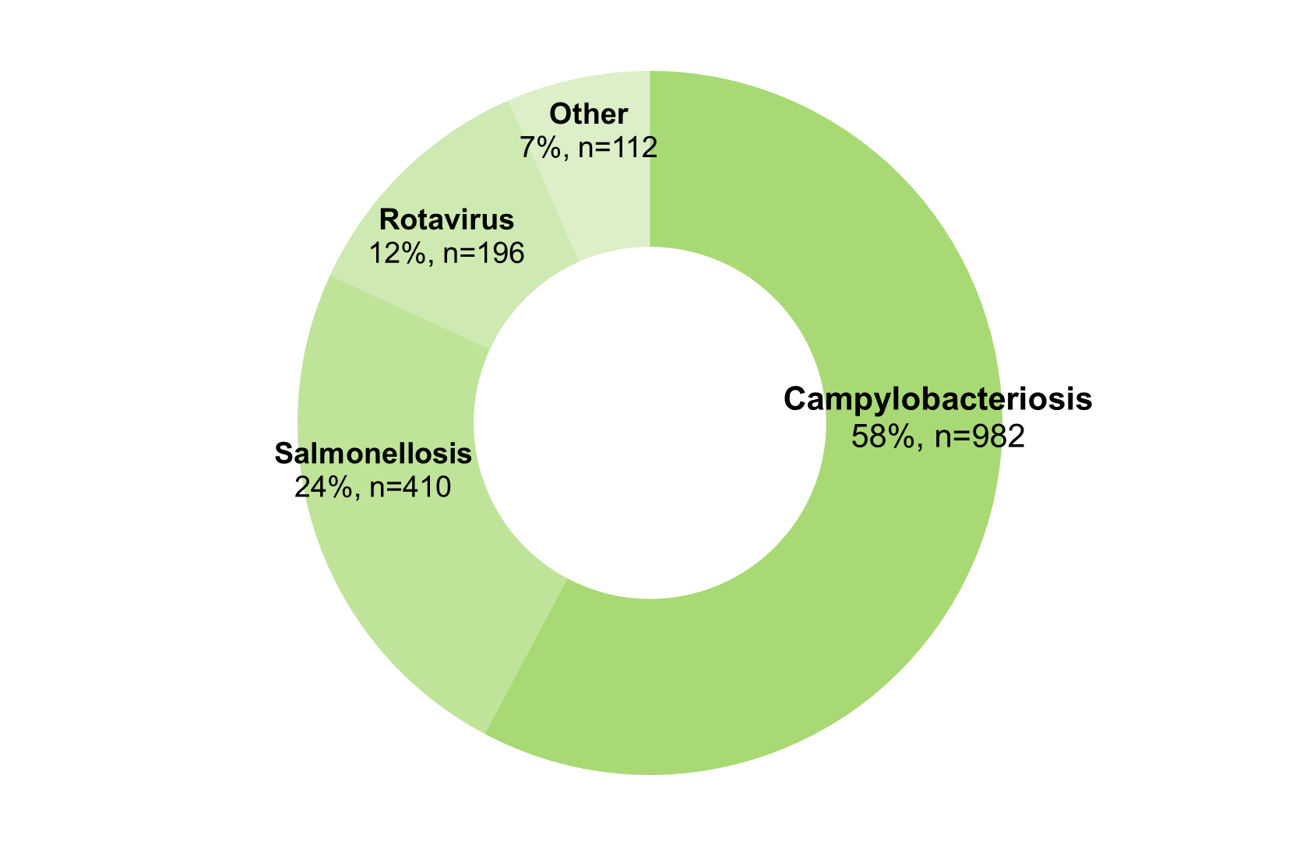

**Appendix 1** Enteric diseases by public health region:

<https://ww2.health.wa.gov.au/~/media/Files/Corporate/general%20documents/Infectious%20diseases/Word/OzFoodNet/WA-OzFoodnet-appendix1-2019-Q3.doc>

*Percentage change in the number of notifications in the current quarter compared to the historical 5-year mean for the same quarter. Positive values indicate an increase when compared to the historical 5-year mean of the same quarter. Negative values indicate a decrease when compared to the historical 5-year mean of the same quarter. Percentage change should be interpreted with caution when the number of cases is small.

**Change in enteric disease notifications (%)\***

**Most common enteric disease notifications in Quarter 3 2019**

**Outbreaks in Quarter 3 2019**

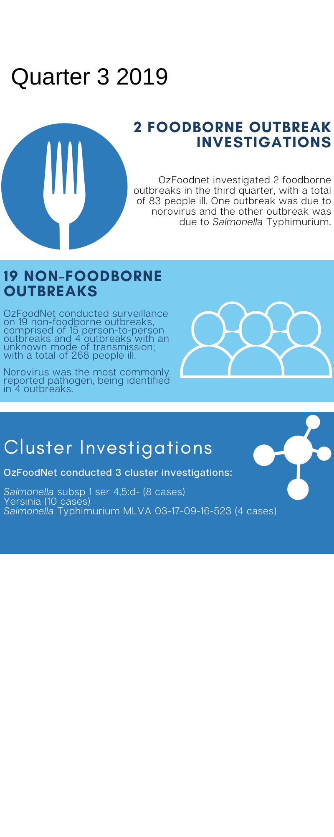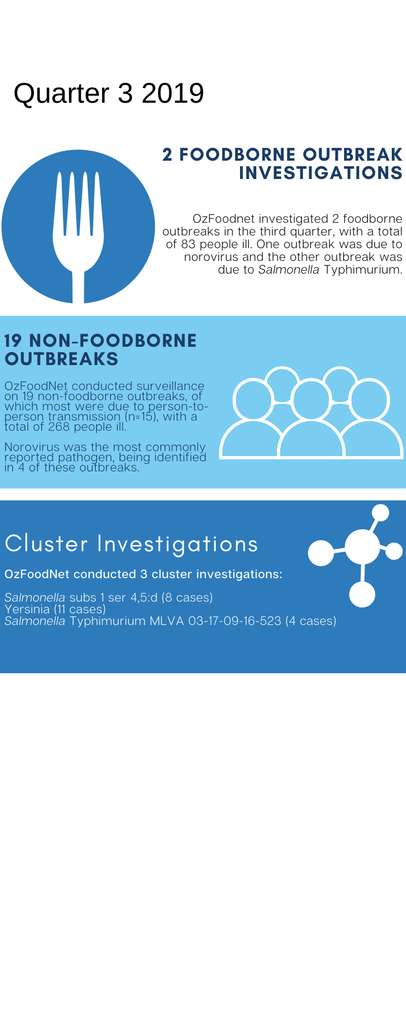

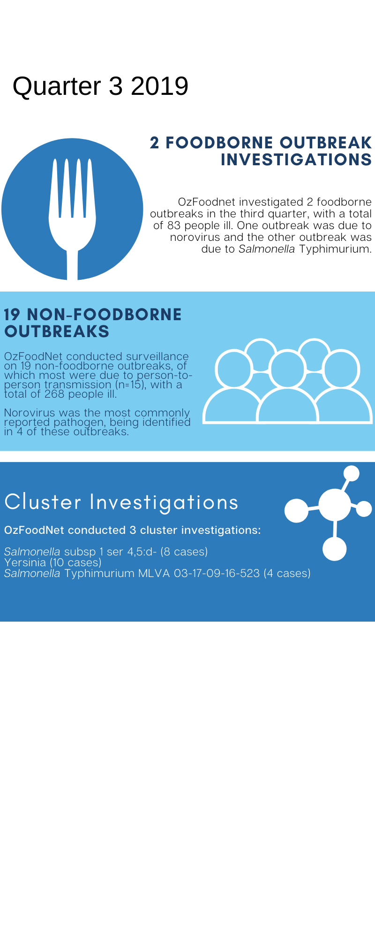

**Appendix 2** Details of foodborne outbreaks investigated in Quarter 3, 2019:

<https://ww2.health.wa.gov.au/~/media/Files/Corporate/general%20documents/Infectious%20diseases/Word/OzFoodNet/WA-OzFoodnet-appendix2-2019-Q3.doc>

**Key trends from Quarter 3 2019**

***Salmonella* Typhimurium (STM) MLVA 03-17-09-12-523**

STM MLVA 03-17-09-12-523 has been under investigation since the type emerged in September 2016. From September 2016 to September 2019 there were 1340 cases notified, including 51 cases in 3Q19. This MLVA type was the single most common MLVA type notified in 3Q19, constituting 12% of STM notifications for the quarter. No point source outbreaks were identified in 3Q19.

Figure: Notifications of *Salmonella* Typhimurium MLVA 03-17-09-12-523 in WA, 2016 to September 2019

Travel associated infection

Overseas acquisition was reported in 296 (17%) of enteric disease notifications in the 3Q19:

* The most commonly reported country of acquisition was Indonesia (67%).

***Listeria***

Two *Listeria* cases were notified in pregnant women in August. Both pregnancies were continuing at the time of interview. Isolates from the cases were different via whole genome sequencing, indicating a common source of infection was unlikely.

**Shiga toxin producing *E. coli* (STEC)**

Ten of the 28 notifications were culture positive, the most common serotypes were O128:H2 (n=4) and O157:H7 (n=2). No point source outbreaks were identified in 3Q19. Some of the increase is likely due to PCR testing by one private laboratory since the fourth quarter of 2018.

***Yersinia***

Eleven cases of *Yersinia enterocolitica* were notified in the metropolitan area between July and August. Ten of the 11 cases reported no recent travel; the case with overseas travel had a *Salmonella* co-infection. Cases were aged 12-76 years, with 10 males and 1 female affected. No common venues or exposures were identified. No hypothesis for cause of illness was established.